Experience

Hong Kong Sesory Choir (Hong Kong) - May,2019 - Present

Principal conductor, teacher (classes of music composing, conducting, vocal ensemble)

Vyborg State Chamber String Orchestra (Russia, Vyborg) — September, 2013 - May, 2017
Artistic director, conductor

Educational theater "Na Mokhovaya" at the Russian State Institute of Performing Arts (Russia, St. Petersburg) — June, 2016 - June, 2018
Pianist

Russian State Institute of Performing Arts (Russia, St. Petersburg) — September, 2016 - May, 2017
Accompanist in the vocal class, arranger

Evangelical Lutheran Church of Ingria (parish of Haapakangas, Russia, St. Petersburg) — December, 2011 - December, 2016
Organist

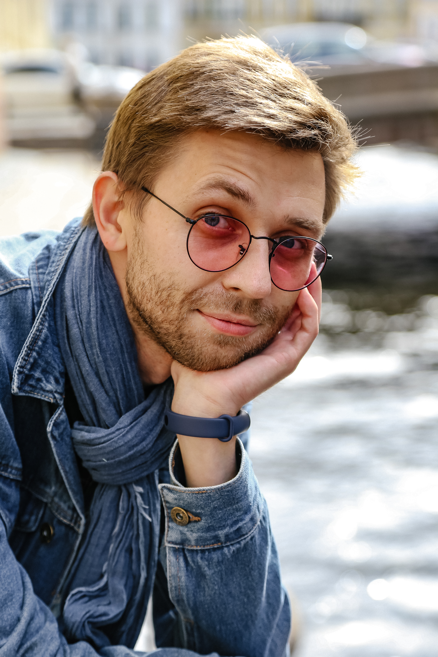
Evangelical Lutheran Church of Ingria (parish of Haapakangas, Russia, St. Petersburg) — July, 2012 - October, 2016
Viktor Ignatev
Personal Info
Viktor Ignatev

Date of birth
February 7th, 1988
Address
Bassejnaja street,85-162,
Saint Petersburg, Russia, 196244
Contact
ignatievvv.com
ignatievvv@gmail.com
+79213218138

Languages
English - Advanced
German - Advanced
Russian - Proficiency

Software
Sibelius, Finale, Cubase, Ableton Live, Microsoft Office

Internships
2008-20012 - An internship with the Chamber Choir of the St. Petersburg Conservatory
2013 - An internship with the Student Choir of the St. Petersburg Conservatory
Artistic director, choir conductor

Evangelical Lutheran Church of Saint Mary (Russia, St. Petersburg) — January, 2014 – January, 2015
Organist

Evangelical Lutheran Church of Saint Mary (Russia, St. Petersburg) — January, 2014 – January, 2015
Choirmaster

Saint Petersburg City Palace of Youth Creativity — August, 2010 - June, 2011
Choirmaster

Composer and arranger — February, February, 2007 – Present

Education
Rimsky-Korsakov St. Petersburg College of Music — Bachelor's degree in conducting, 2004-2008
St. Petersburg State Conservatory Conductor — Master's degree in conducting, 2008-2013

Master courses
Conducting
Viktor Yampolsky (Director of orchestral program; Northwestern University; Music Director: Peninsula Music Festival; Music Director Emeritus: Omaha Symphony; Honorary Director: Scotia Festival of Music); Yuri Simonov (Music Director, Moscow Philharmonic Orchestra); Yuri Temirkanov (Music Director and Chief Conductor of the Saint Petersburg Philharmonic); Boris Abalyan (Professor of the St. Petersburg State Conservatory, Chief Conductor of the Gracias Choir); Georg Christoph Sandmann (Professor of the orchestral conducting at the Higher School of Music of Karl Maria von Weber, Germany Dresden).
Piano
Pavel Egorov (Professor of the St. Petersburg State Conservatory).
Organ
Ton Koopman (Honorary professor of the Lübeck High school); Johann Trummer (Professor of the University of Graz).

Competitions
2009 - Winner of Piano Competition in the Kazan State Conservatory
2011 - Winner of Piano festival «Piano Duo IX» in the Petrozavodsk State Conservatory
2012 - Winner of Piano festival «Piano Duo X» in the Petrozavodsk State Conservatory
2017 - Grand Prix of the festival «Stars of The Albion», London, England (composer of the performance)

