Biography

Victor Ignatiev

ignatievvv.com

Victor Ignatiev was born on February 7, 1988.
At the age of three, he started practicing music. The first musical lessons were taken with his mother, professional violinist. From 1995 to 2004, he learned music at Saint Petersburg musical school named after E. A. Mravinsky as a pianist.
After the musical school, Victor had entered the musical college named after N. A. Rimsky-Korsakov, where studied up to the year 2008, as a choir conductor in the class of honored art worker of Russia, professor Boris Abalyan. During the education at musical college, he had an internship with the mixed choir and the female choir of the college. Theoretical subjects were studied in the class of Tatiana Babanina, and the arrangement was studied in the class of Michail Serkov.
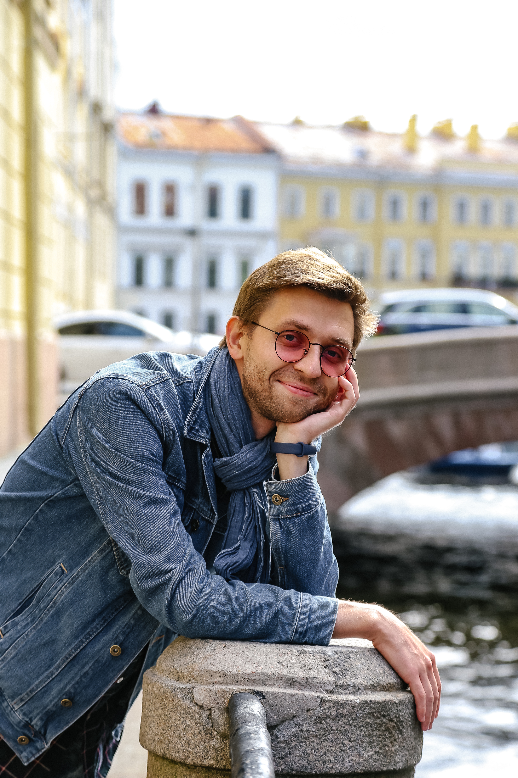
From 2008 to 2013, Victor studied conducting at the Saint Petersburg State Conservatory named after N. A. Rimsky-Korsakov in the class of honored art worker of Russia, professor Boris Abalyan. At the period, he had an internship with the Chamber Choir of the St. Petersburg Conservatory (2008-2012) and with the Student Choir of the St. Petersburg Conservatory (2013).
The course of piano was studied in the class of the assistant professor of the Saint Petersburg State Conservatory named after N. A. Rimsky-Korsakov and professor of the Petrozavodsk State Conservatory named after A.K. Glazunov Tatiana Borisova. During the study Victor become a prizewinner of All-Russian competition and international festivals as a pianist. Also, he studied the circle of theoretical subjects: the course of harmony (with Professor Oleg Sokolov); the course of renaissance and baroque counterpoint (with assistant professor Galina Abdulina); the course of analysis of musical forms (with the professor Igor Rogalev); the course of history of music (with assistant professors Tamara Tverdovskaja, Galina Nekrasova and professors Ivan Fedoseev, Ludmila Skaftimova); the course of arangemet (with assistant professor Sergey Pleshak). In the yeah 2013 Victor graduated the conservatory as a conductor (Master’s degree). Victor studied the organ and harpsichord playing (with assistant professors Andrej Kolomijcev and Marina Viajzja). Also, Victor has practiced conducting with Alexander Polishchuk.
During the education in the conservatory and after that, Victor took part in different international conducting masterclasses by such famous conductors, as Yury Simonov (music director and chef-conductor of Moscow Philharmonic Orchestra), Victor Yampolsky (director of orchestral program; Northwestern University; music director: Peninsula music festival; music director Emeritus: Omaha Symphony; honorary director: Scotia festival of music), Yuri Temirkanov (music director and chief conductor of the Saint Petersburg Philharmonic) Boris Abalyan (honored art worker of Russia, professor of the St. Petersburg State Conservatory, chief conductor of the Gracias Choir). In addition, he took part in international master classes as a pianist and as an organist: Pavel Egorov (professor of the St. Petersburg State Conservatory), Ton Koopman (honorary professor of the Lübeck High school of music), Johann Trummer (professor of the University of Graz).
Victor practiced conducting with Alexander Rumpf (professor of High school of music, Cologne, Germany) and Georg Christoph Sandmann (professor of High school of music, Dresden, Germany).
After graduation of the conservatory, Victor founded a chamber string orchestra (Vyborg state chamber string orchestra), where he was working as an artistic director and a chief conductor until the year 2017.
Since the year 2014 Victor regularly have taken part in the projects, that are connected with development of the modern electronic music. In the year 2017, the theatrical performance “A soul of a clown” won a Grand Prix of the festival "Stars of The Albion" (London, England).The music for the theatrical performance was written by Victor Ignatiev.
Also, he has professional work experience as an organist. A few years Victor worked in a dramatic theater and in the Theater Academy as a pianist and accompanist.
Since 2019, Victor has a position of the principal conductor of the Hong Kong Sesory Choir.
In addition, Victor is a developer of individual educational programs for the subjects: theory of musical elements, counterpoint (renaissance and baroque), classical harmony, piano playing, organ playing, harpsichord playing.

